Week 11 Project Documentation
Weather Application with API Integration
1. Project Overview
The Weather Application is a Java-based desktop application that provides weather information for a selected city using the OpenWeather API.
The main objectives of the project are:
- To understand HTTP communication and REST API integration.
- To retrieve real-time weather data from an external API.
- To parse JSON responses using the Jackson library.
- To develop a desktop graphical user interface using Java Swing.
- To display current weather and forecast information.
- To implement caching to reduce repeated API requests.
- To handle network errors, API errors, and request timeouts.
- To provide basic weather alerts based on weather conditions.

2. Setup Instructions
Software Requirements:
- Java JDK 21
- Eclipse IDE
- Apache Maven
- Internet connection
- OpenWeather API account
Installation and Configuration Steps:
- Install Java JDK 21 and configure it in Eclipse.
- Open the WeatherApp Maven project in Eclipse.
- Allow Maven to download the required project dependencies.
- Create an API key from OpenWeather.
- Set the API key as a Windows environment variable:
OPENWEATHER_API_KEY
- Restart Eclipse after configuring the environment variable.
- Run the Main.java file.
- The Weather Application GUI will open.

3. Code Structure
The project follows a modular package structure to separate API communication, data models, GUI, caching, and alert handling.
WeatherApp
│
├── pom.xml
│
└── src
└── main
└── java
└── com.weatherapp
│
├── Main.java
├── ApiTest.java
│
├── models
│ ├── WeatherData.java
│ └── ForecastData.java
│
├── api
│ └── WeatherApiClient.java
│
├── gui
│ └── WeatherAppGUI.java
│
├── cache
│ └── CacheManager.java
│
└── alerts
└── WeatherAlerts.java

4. Visual Documentation
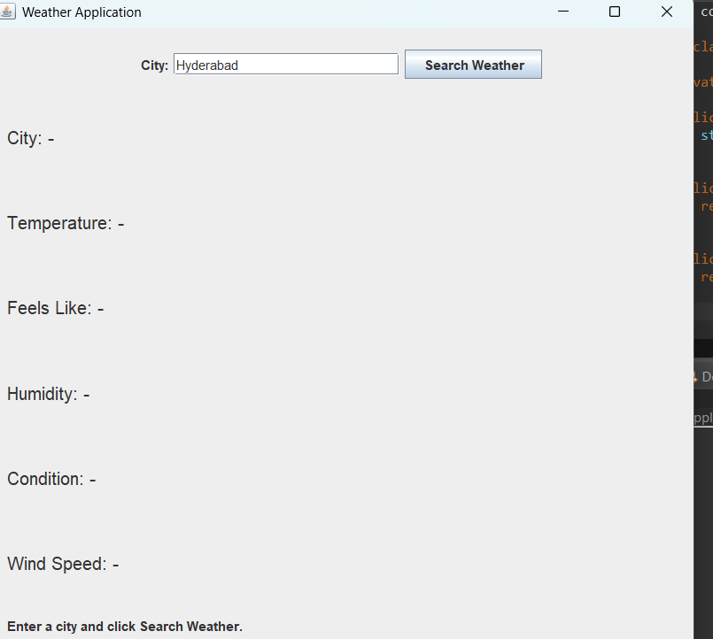

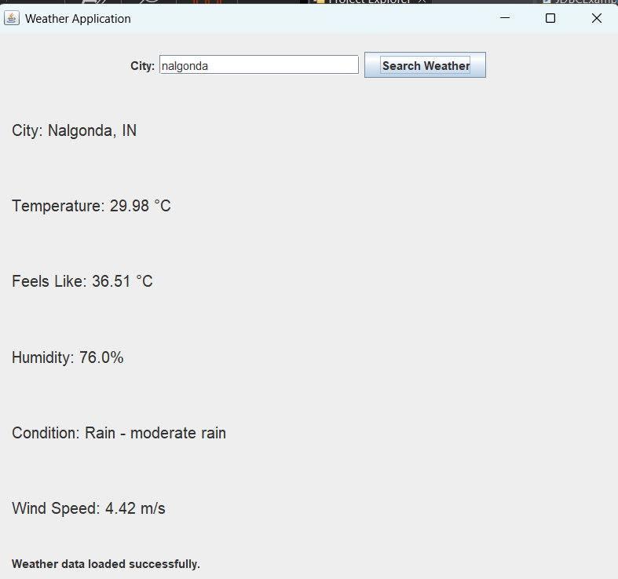
5. Technical Details
HTTP and REST API
The application uses Java's HttpClient to communicate with the OpenWeather REST API. HTTP GET requests are used to retrieve current weather and forecast information.
JSON Processing
The OpenWeather API returns weather information in JSON format. The Jackson ObjectMapper is used to convert the JSON response into Java objects such as WeatherData and ForecastData.
Caching
The CacheManager uses ConcurrentHashMap to temporarily store weather information by city. Cached data is retained for a limited period to reduce unnecessary API requests.
Graphical User Interface
The application uses Java Swing to provide the desktop interface. Users can enter a city name and search for weather information. SwingWorker is used to perform network operations without blocking the GUI.

6. Testing Evidence
The application was tested for API communication, JSON processing, GUI functionality, caching, forecast retrieval, and error handling.
Test Case | Expected Result | Result
API Key Configuration | API key is read successfully | Pass
Weather API Request | Weather data is retrieved | Pass
JSON Parsing | JSON is converted into Java objects | Pass
GUI Startup | Application window opens successfully | Pass
City Search | Weather information is displayed | Pass
Forecast Retrieval | Forecast information is retrieved | Pass
Caching | Cached weather data can be reused | Pass
Error Handling | Errors are handled and displayed | Pass
Weather Alerts | Alert is generated for supported conditions | Pass

